**TOPICS**: insert here the conference subtheme

Concise and Informative Article Title, Capitalize first letter

First Author1, Second Author2, Third Author1

1 Institute 1 Address, City and Postcode, Country

2 Institute 2 Address, City and Postcode, Country

Corresponding author: corresoponding.author@email.address.com

**Abstract.** Authors are invited to submit a paper which should include introduction, material and methods, results and discussion, conclusions and references. To be accepted for publication, the submissions must report work that is novel, well described, and suited to the Conference themes. Submissions must contain original data and meet international ethical standards. Selection criteria include high technical quality, relevance to the conference themes, and significant information content. Papers that are deemed commercial in nature will not be accepted. (abstract about 300~400words).

**Keywords:** 3–6 keywords (in alphabetical order)

*CRITICAL: Do Not Use Symbols, Special Characters, Footnotes, or Math in Paper Title or Abstract.

1. Layout

Spacing and paragraphs

The manuscript must use 10.5 pounds with 1.5 line spacing. Each paragraph must be indented by 2 characters.

Page

Manuscripts must contain page numbers. Page numbers must appear on all pages of text, including references, figure captions, and tables.

Headings

It is necessary for you to distinguish the categories of headings in your manuscript. The subsections and their headers must be organized in a logical hierarchy, using first-order (1., 2., etc.), (optionally) second-order (1.1., etc.), third-order (1.1.1., etc.), and forth-order ((1), (2), etc.) numbers.

The Category1 heads must use12 pounds.The Category2、Category3 and Category4 heads must use11 pounds.

Place heads at the left margin (without indentation), with only the first word of the heading and proper nouns capitalized. Start the text that follows on the next line and indent it.

1. Figures

All figures should be numbered with Arabic numerals (1, 2, 3….). In the caption and text, spell out the word “Fig.” when a number follows it. Each figure should be called out (mentioned) sequentially in the text of the paper. Every figure should have a caption. Captions should be explicit enough that the reader can understand the significance of the illustration without reference to the text. All photographs, schemas, graphs and diagrams are to be referred to as figures. Line drawings should be good quality scans or true electronic output. Low-quality scans are not acceptable. Figures must be embedded into the text and not supplied separately. Lettering and symbols should be clearly defined either in the caption or in a legend provided as part of the figure.

If a figure consists of multiple panels, they should be ordered logically and labelled with lower case roman letters (i.e., (a), (b), (c), etc.). Every label should be followed by a sub-title and be included in the figure itself.

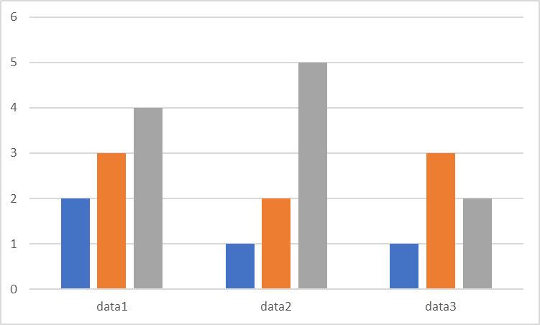

Figure 1 Figure caption [Times New Roman, 11pt, centred]

1. Tables

Each table should be given an Arabic number and should be referred to by that number in the text. In the caption and text, spell out the word “Table” when a number follows it.Each table should be called out (mentioned) sequentially in the text of the paper.Headings should be placed above tables, centred. Only horizontal lines should be used within a table, to distinguish the column headings from the body of the table, and immediately above and below the table. Tables must be embedded into the text and not supplied separately. Tables should be provided as editable text and not as images.If numerical measurements are given, the units should be included in the column heading. Vertical rules should not be used.Below is an example which the authors may find useful.

Table 1 Table caption [Times New Roman, 11pt, centred]

|  |  |  |
| --- | --- | --- |
| Text | Text | Text |
| Text 1(m/s) | 5 | 5 |
| Text 2(m2) | 6 | 2 |
| Text 3(kg) | 2 | 1 |

1. References

References must be listed at the end of the paper. Authors should ensure that every reference in the text appears in the list of references and vice versa. Indicate references by [1] or [2,3] in the text.

Some examples of how your references should be listed are given at the end of this template in the ‘References’ section, which will allow you to assemble your reference list according to the correct format and font size.

Equations

Equations and formulae should be typed in Mathtype, and numbered consecutively with Arabic numerals in parentheses on the right hand side of the page (if referred to explicitly in the text). They should also be separated from the surrounding text by one space.

Follow internationally accepted rules and conventions: use the international system of units (SI). If other units are mentioned, please give their equivalent in SI, e.g. 2,200 m/s (7,200 ft/s).

All of the following conform to SI metric standards: s for second; Hz as unit, hertz as word; J as unit, joule as word; N as unit, newton as word; W as unit, watt as word; Pa for pascal; kPa for kilopascal; MPa for megapascal; GPa for gigapascal; m/s for meter per second; 1,000 (with a comma); one space between number and unit (10 m, not 10m); ms for millisecond; cm for centimeter; mm for millimeter; µm for micrometer; µs for microsecond; nm for nanometer.

 (1)

Reference

[1] GEER J V D, HANRAADS J A J, Lupton R A. The art of writing a scientific article[J]. Journal of Personality and Social Psychology, 2000, 83:1456-1468.

[2] STRUNK JR W, WHITE E B. The Elements of Style[M]. 3rd ed. New York:Macmillan, 1979.

[3] WEINSTEIN L, SWERTZ, M N. Pathogenic properties of invading microorganism[M]//SODEMAN W A, Jr,SODEMAN W A. Pathologic physiology: mechanisms of disease. Philadelphia: Saunders, 1974: 745-772.

[4] CALMS R B. Infrared spectroscopic studies on solid oxygen[D]. Berkeley:Univ. of California, 1965.